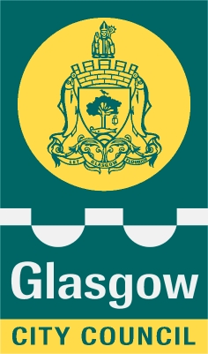

Glasgow City Council

Education Services

Privacy Statement
As the local authority our schools and early years establishments process information about children and young people in order to help administer education and care. In doing so we must comply with the Data Protection Act (1998).
This means (amongst other things) that the data held about children and young people must only be used for specific purposes allowed by law. The following information explains the types of data held, why that data is held, and to whom it may be passed on.

Types and use of data
Data held by schools and educational establishments includes contact details, curriculum assessment results, attendance information, characteristics such as ethnic group, additional support needs and any relevant medical information.
Our data includes information about individuals for whom it provides services, and the details of services provided. This data helps us:
- support learning and teaching
- monitor and report on progress
- provide appropriate pastoral care
- assess how well the school/establishment and Council are doing as a whole
- monitor progress and develop good practice in the services received
- carry out specific functions (such as social care)
- to evaluate and develop education policy and strategies
In addition, we may use this information for other legitimate purposes and may share this information where necessary with other bodies responsible for administering services to children and young people or where otherwise required by law.

We also hold information about parents/carers, emergency contacts etc. that is provided in the annual data check. This allows us to carry out the Council’s functions as the education authority and may sometimes involve releasing personal information to other agencies and other parts of the Council, particularly in relation to child protection issues or criminal investigations, and it may also be used for research purposes (see the link below for more details regarding this).

Information held by the school is, in legal terms, processed by Glasgow City Council. The Council is registered as a data controller under the Data Protection Act 1998 (number Z4871657) and all personal data is treated as confidential and used only in accordance with the Data Protection Act and the Information Use and Privacy Policy approved by the City Council. For more information on how we use personal information, or to see a copy of the Information Use and Privacy Policy, see www.glasgow.gov.uk/privacy.

Data rights and access
As a data subject (or the parent of a data subject), you have certain rights under the Data Protection Act, including a general right to be given access to personal data held by any data controller.
The presumption is that by the age of 12 a child has sufficient maturity to understand their rights and to make an access request themselves if they wish. If you are a parent of a child younger than 12, you would normally be expected to make a request on their behalf.
The Council may use this information for other legitimate purposes and may share this information where necessary with other bodies responsible for administering services to children and young people or where otherwise required by law. The Council also has a duty to protect the public funds it administers, and to this end it may use the information you have provided for the prevention and detection of fraud.

