St Benedict's Primary School

St Benedict's Primary
Handbook

Handbook

Believe Achieve Succeed

Updated August 2020

INFORMATION ABOUT
ST BENEDICT’S PRIMARY

62 Lochend Road
Glasgow G34 OLT
Tel 0141 771 3224
Fax 0141 771 3711
e-mail headteacher@st-benedicts-pri.glasgow.sch.uk
website address www.st-benedicts-pri.glasgow.sch.uk/
Twitter @Stbenedictsps
Acting Head Teacher: Ms Jacqueline Daly

Roman Catholic Primary School

Co-educational

Stages Taught: P1 - P7

Present Roll: 419
Planning and Working Capacity: 466

Parents should note that the working capacity of the school may vary dependent upon the number of pupils at each stage and the way in which the classes are organised

ST BENEDICT’S PRIMARY SCHOOL
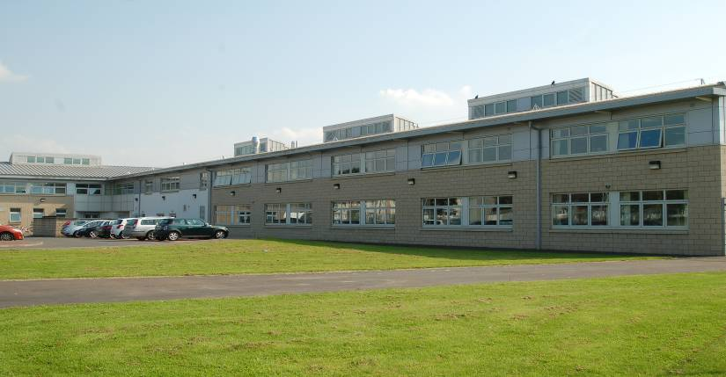

Saint Benedict’s Primary is a Catholic school situated in the revitalised Easterhouse area of Glasgow’s east end.

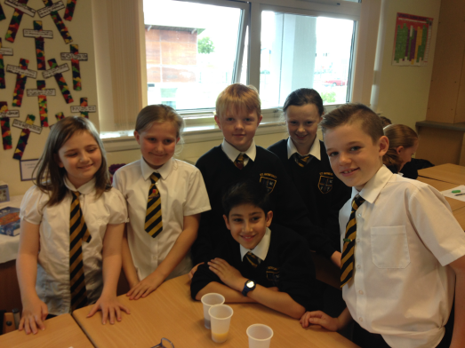
The school has always had a proud history in the area and building on this historic tradition, but with a view to taking St. Benedict’s forward, it is our aim to work in partnership with you, the Church, partner agencies and the wider community to develop in our young people the four capacities,
‘Confident Individual’, ‘Successful Learner’, ‘Effective Contributor’ and ‘Responsible Citizen’ of Curriculum for Excellence.

The school is part of the Saint Andrew’s Learning Community. This involves working together with 6 partner primary schools, 2 partner nurseries and St Andrew’s Secondary School in order to strengthen our efforts in raising attainment and achievement across the community. As the Headteacher, I look forward to working with all those involved in the school community and continuing St Benedict’s ‘journey to excellence’ through the school’s revised vision, values and aims.

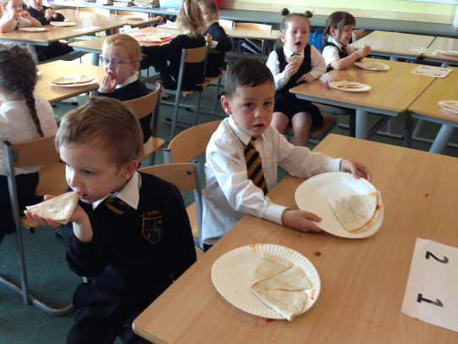
Jacqueline Daly
Acting Headteacher

School staff
A full list is available on the school website/school app and parents will be updated on any changes as required.

The leadership team is as follows:

Headteacher Jacqueline Daly
Depute Tony Byatt
Principal Teacher Patricia Ryan
Principal Teacher Audrey McKee
Principal Teacher Jacqueline Murphy
Principal Teacher Heather Sludden
Principal Teacher Katie Brogan

Enrolment
Registration of Primary 1 children takes place in November and is advertised widely in local press etc. Prospective parents are welcome to visit the school and should contact the school office. Enrol is now conducted online – see the link below.

Families living outwith the catchment area are welcome to make a placing request to attend Glasgow Primary School but must enrol their child online as a first step. Further information is available using the following
https://www.glasgow.gov.uk/index.aspx?articleid=18426

Organisation of Classes

The following guidelines set by Scottish Government apply.
P1 maximum 25
P2&3 maximum 30
P4-7 maximum 33
Composite classes maximum 25

Composite classes have pupils from more than one stage.

Believe Achieve Succeed

Visions, Values & Aims

Our Vision

Believe Achieve Succeed

Our vision in St Benedict’s is to empower and equip children to be the best they can be. Everyone will be included, nurtured and respected in an environment based on Gospel Values.

Our Values

PEACE TRUST HARMONY RESPECT

Our Aims

Working as a team and with our community we aim to:

- Create an ethos that promotes an inclusive environment
- Encourage children to reach their full potential through opportunities and challenge
- Equip children with the skills for learning, life and work
- Develop a positive mindset that embeds resilience, respect and citizenship
- Promote healthy lifestyles in an environment of mutual trust and respect
- Nurture the whole child in an environment based on Gospel Values
- Work in partnership with all stakeholders and will learn from looking inwards, outwards and forwards.

Welcome to St Benedict’s Primary School
Child Welfare & Safety
and Child Protection

All educational establishments and services must take positive steps to help children and young people protect themselves by ensuring that programmes of health and personal safety are central to the curriculum and should have in place a curriculum that ensures that children/young people have a clear understanding of the difference between appropriate and inappropriate behaviour on the part of another person, no matter who.

At St Benedict’s Primary we maintain a positive ethos and climate which actively promotes children and young people’s welfare and a safe environment by:

- Ensuring that children and young people are respected and listened to.

- Ensuring that programmes of health and personal safety are central to the curriculum.

- Ensuring that staff and visitors are aware of child welfare and safety and protection issues and procedures.

- Establishing and maintaining close working relationships and arrangements with all other agencies to make sure that professionals collaborate effectively in protecting children and young people.

Should our visitors have any concerns regarding the welfare or safety of any child they must report these concerns the Headteacher or the person deputising for the Headteacher, after judging that there may be grounds for concern regarding the welfare or safety of any child in St Benedict’s Primary.

***Please note that Jacqueline Daly, Acting Headteacher, is the Child Protection Coordinator.

If Mrs Daly is out of school, please report to our Depute Headteacher, Mr Byatt.

THE SCHOOL DAY

Morning: 09.00am - 10.30am
(Interval P4-P7 10.30am - 10.45am)
(Interval P1-P3 10.45am - 11.00am)

Lunch: 12.15pm - 1.00pm
12.30pm - 1.15pm

Afternoon: 1.00pm. – 3.00pm.

Organisation of Classes
The following guidelines set by Scottish Government apply.
P1 maximum 25
P2&3 maximum 30
P4-7 maximum 33
Composite classes maximum 25

Composite classes have pupils from more than one stage.

Enrolment
Registration of Primary 1 children takes place in November and is advertised widely in local press etc. Prospective parents are welcome to visit the school and should contact the school office. Enrol is now conducted online – see the link below.

Families living outwith the catchment area are welcome to make a placing request to attend Glasgow Primary School but must enrol their child online as a first step. Further information is available using the following:
https://www.glasgow.gov.uk/index.aspx?articleid=18426

School Holidays
Details of holiday dates are available on the Glasgow City Council website: https://www.glasgow.gov.uk/index.aspx?articleid=17024

Pupil Absence
Within Glasgow Primary Schools, good attendance is encouraged at all times and children are rewarded accordingly. Parents are asked to advise if their son or daughter is going to be absent. This should be done as early as possible on the first day of absence. If the young person is going to be absent for some time, it would be helpful to know at the earliest opportunity. The school uses daily text messaging to inform parents and carers of absence if no contact is made. All unexplained absence is investigated by the school and appropriate action taken. All calls must be made to the Pupil Absence Reporting Line on 0141 287 0039. The line is open between 08.00-15.30 Monday to Friday. Alternatively you can use the online form on the Glasgow City Council website: https://www.glasgow.gov.uk/index.aspx?articleid=18832
Curriculum for Excellence 3-18
Curriculum for Excellence has been introduced to raise standards of learning and teaching for all 3 to 18 year olds. It aims to help prepare children and young people with the knowledge and skills they need in a fast changing world. As part of Curriculum for Excellence all children from pre-school to the end of S3 will receive a rounded education known as a Broad General Education(BGE). Curriculum for Excellence is all about bringing real life into the classroom and taking lessons beyond it.

Through the experiences we provide at St Benedict’s Primary School we want our children to become Successful Learners, Confident Individuals, Responsible Citizens and Effective Contributors. We are committed to providing children with a broad general education and focus on eight curriculum areas.

Expressive Arts | Health & Wellbeing | Languages | Mathematics
Religious & Moral | Sciences | Social Studies | Technologies

Progress in learning is indicated through curriculum levels as detailed below.

Level | Stage
Early | The pre-school years and P1 or later
First | To the end of P4, but earlier or later for some
Second | To the end of P7, but earlier or later for some
Third & Fourth | S1-S3, but earlier for some

Expressive arts: The inspiration and power of the arts play a vital role in enabling our children and young people to enhance their creative talent and develop their artistic skills.

Health and wellbeing: Learning in health and wellbeing ensures that children and young people develop the knowledge, understanding and skills which they need now and in the future, to help them with their physical, emotional and social wellbeing.

Science: Science and its practical application in healthcare and industry is central to our economic future, for our health and wellbeing as individuals and as a society.

Social Studies: Through social studies, children and young people develop their understanding of the world by learning about other people and places both past and present, societies, their beliefs and values.

Religious and moral education: Religious and moral education includes learning about Christianity, Islam and other world religions, and supports the development of beliefs and values.

Languages: Knowing other languages and understanding other cultures is a 21st century skill set for students as they prepare to live and work in a global society.

Mathematics: Mathematics equips us with the skills we need to interpret and analyse information, simplify and solve problems, assess risk and make informed decisions.

Technologies: The range of subjects in technical education has changed significantly over the last two decades and now includes craft, design, engineering and graphics.

There will be opportunities throughout the year for parents and carers to learn more about aspects of the curriculum and to be consulted about significant changes if appropriate.

Useful websites
www.curriculumforexcellencescotland.gov.uk
www.educationscotland.gov.uk/parentzone/index.asp

Home Learning
Continuing to learn at home helps children to achieve more and is a vital part of our partnership with parents. Please check your child’s schoolbag for communication about home learning and specific tasks. A copy of our home learning policy is available on the website and on request from the school office. Consultation with parents, staff and children have led us to a new homework policy. This is available for download via our school App St Benedict’s RC Primary via Scoted on App Store and Google Play.

Support for Pupils
The school has a duty to ensure that all pupils have equal access to the curriculum, with appropriate support for their needs if required. This applies to the content of lessons, teaching strategies and minor adaptations to the school environment. There are a wide range of factors which may act as a barrier to learning. We are committed to working closely with parents and carers to ensure that they are fully involved in any decisions about support for their children’s needs. Any parent or carer seeking further advice regarding this policy should contact the Headteacher in the first instance.

Further information relating to additional support needs is available on the Glasgow City Council website at https://www.glasgow.gov.uk/index.aspx?articleid=18941
Information on the Glasgow City Councils’ Parental Involvement Strategy can also be found at https://www.glasgow.gov.uk/index.aspx?articleid=17870

RELIGIOUS EDUCATION
St Benedict’s Primary is a Roman Catholic School which endeavours to develop the children socially, morally, spiritually, and educationally within a community of Faith and Learning. Not only is this done through the Religious Education Programme ‘This is Our Faith’ but throughout the curriculum, and by the example of the staff within the school community.
‘This is Our Faith’ is the Religious Education Programme followed, it was introduced last year and staff also follow Sacramental programmes for First Reconciliation, First Communion & Confirmation. Talks to parents on the Sacraments and other aspects of the R.E. Programme are arranged as required, to allow parents to fulfil their role as the first and most important educators of their children.
Parents have the right to withdraw their child from religious observance and should inform the school in writing. In addition, parents and carers from religions other than Christianity may request that their children may be permitted to be absent from school in order to celebrate recognised religious events. Only written requests detailing the proposed arrangements will be considered. Appropriate requests will be granted on up to 3 occasions in any 1 school session.
The school is supported in its work by Fr Thomson the Parish Priest of John Bosco Parish.

Assessment & Reporting
Assessment & Reporting All children are assessed both formally and informally throughout the year. This allows children and their teachers to identify their strengths and areas for improvement. A variety of assessment methods are used to enable staff to pass on information to parents about the progress of their child. Assessment records are kept by the class teacher and form the basis of discussion at Parents’ Evenings in November and March. An annual report is sent to parents towards the end of each school year. If you have any concerns about your child’s progress do not hesitate to contact the school.

Pupil Profiles
Every child leaving primary school in Scotland has their key achievements in school, at home and in the community documented within a P7 profile. The content of the profile is decided by the young person. The profile is a positive record of their achievements and emphasis their strengths. The profile provides a valuable way for learners to share valuable information about their achievements with their parents and teachers in secondary school.

Promoting Positive Behaviour
Children’s Rights as outlined in the UNCRC (United Nations Convention on the Rights of the Child) are fundamental to a good school ethos. Adults in our school will work with children to ensure they are aware of their rights and fully respect the rights of others. Therefore, the approach within St Benedict’s Primary School is to build a positive ethos that demonstrates care and respect for all. Positive behaviour is recognised and celebrated. Our school operates a system of class charters to set out expected behaviour. This is celebrated through Golden Time, awards at assemblies and certificates sent home to parents etc. The highest standards of behaviour are expected of pupils at all times. Where this is not the case, a variety of sanctions are used. Parents are asked to co-operate with the school in encouraging a sense of responsibility and good behaviour in their children.

Extra Curricular Activities
We have a wide range of activities that run between Monday – Friday to extend the learning experience, such as dance and football.. Please check your child’s schoolbag and school App for information as places are popular and usually limited. Good links with community organisations and our Active Schools Co-ordinator are vital for the success of these programmes. Throughout the year the children enjoy educational excursions and visits to a variety of museums and places of interest, these are an important part of the curriculum at St Benedict’s.

Nurturing City
The Glasgow City Council vision ‘towards the nurturing city’, puts building positive, trusting relationships at the core of our work. We ensure children, young people and families feel they belong, they are listened to and they are valued by embedding the principles of nurture across our early years, primary and secondary establishments. Staff are trained in attachment and nurture which deepens understanding of child development and enhances effective practice by responding to the needs of all children and young people in a consistent and caring way. Nurture is a universal approach which builds resilience, helping to reduce the impact of adversity. Effective communication and collaboration with parents and carers builds an ethos of partnership working putting the child at the centre, fostering high quality learning contexts. Each of our nurturing establishments contribute to the development of Glasgow as a nurturing city, creating safe environments which allow our children and young people to flourish by raising attainment and promoting positive mental health and wellbeing.

Communication with Parents
At St Benedict’s Primary School we use a variety of methods of communication:

Open Door Policy – the senior leadership team are available for all parents and carers at any time providing they are not teaching or in another meeting. Please either pop in to the school office or phone for an appointment.

Newsletters – will be available on a regular basis to keep parents informed about the work of the school.

Letters – further information which requires a response may be sent out in letter form.

Twitter/App – will contain a great deal of information about the school. It is a good idea to check this regularly.

School website – will contain a great deal of information about the school. It is a good idea to check this regularly http://www.st-benedicts-pri.glasgow.sch.uk/

Text messaging – You may also receive text reminders about events/school closures etc.

Meetings - Parents and carers are welcome in the school to discuss any aspect of their child’s development and progress. To avoid disappointment and in lines with Scottish Government recommendation of Social Distancing it is advisable to make an appointment. There are various opportunities throughout the year when parents can discuss their child’s progress with the class teacher and view the child’s work – as advised by GCC on social distancing rules.

Parents and carers are welcome at other events throughout the school year e.g. workshops, information evenings, class performances, religious and other assemblies - as advised by GCC on social distancing rules. The school newsletter, website, twitter and App will keep you informed.

Emergency Contact Information
At the start of each school session, parents will be issued with the annual data check form. Please ensure that this is completed and returned to the school. It is also important that you let us know if there are changes to your telephone number(s) or to those of your emergency contacts throughout the year.

Data Protection – use of information about children and parents/carers
We collect information about children attending school (and also about parents/carers, emergency contacts etc. provided in the annual data check) to allow us to carry out the Council’s functions as the education authority for the City of Glasgow. This may sometimes involve releasing personal information to other agencies and other parts of the Council, particularly in relation to child protection issues or criminal investigations, and it may also be used for research purposes (see the link below for more details regarding this).

Information held by the school is, in legal terms, processed by Glasgow City Council. The Council is registered as a data controller under the Data Protection Act 2018 and all personal data is treated as confidential and used only in accordance with the Data Protection Act, the General Data Protection Regulations, and the Information Use and Privacy Policy approved by the City Council. For more information on how we use personal information, or to see a copy of the Information Use and Privacy Policy, see https://www.glasgow.gov.uk/index.aspx?articleid=18010 .

Education specific privacy statements can be accessed at https://www.glasgow.gov.uk/index.aspx?articleid=22069 .

Appointments during school hours
If your child has an unavoidable appointment, please give them a letter for their class teacher and then collect them from the school office at the specified time.

Comments & Complaints
In St. Benedict’s Primary School we aim to have positive relationships across our school community. However, if you have a comment or complaint about any aspect of school life, please contact the Headteacher in the first instance.

Glasgow City Council complaints procedures are available : https://www.glasgow.gov.uk/index.aspx?articleid=16133

Customer Care Team
Customer & Business Services
Glasgow City Council
City Chambers
Glasgow G2 1DU

Tel: 0141 287 0900
e-mail: customercare@glasgow.gov.uk or education.customercare@glasgow.gov.uk

The above website also includes information on data protection and freedom of information.

School Improvement
On an annual basis, a copy of our Standards and Quality report will be available via the App and the school website. Copies from previous years are available on the school website. The Standards and Quality report highlights progress in key curricular areas such as literacy, numeracy and health & wellbeing. Our priorities for improvement are detailed in our School Improvement Plan which is discussed with our Parent Council. Any parent or carer seeking a copy of the plan can contact the school office or check out our App. Our Standards and Quality report on last session’s performance along with the School Improvement Plan is available on the school website and App.

Clothing & Footwear Grants
Parents/Carers receiving Income Support, Job Seekers Allowance (Income Based), Working Tax Credit (with a total annual income of less than £15,860*), Housing Benefit, Council Tax Benefit or Universal Credit (where the total income is less than £7320) will normally be entitled to monetary grants for footwear and clothing for their children. Information and application forms may be obtained from schools and at
https://www.glasgow.gov.uk/index.aspx?articleid=17885

The school uniform for St Benedict’s Primary includes

Sweatshirts with school badge (black) Black skirt/trousers
White shirts Plain black outdoor shoes
Tie (school colours)
Black sandshoes are worn inside the building.

PE Kit
It is important that pupils come prepared to learn and for PE this requires appropriate clothing. All jewellery should be removed. Pupils who are not participating in PE must have a note or a medical certificate. Pupils who are unable to participate in practical PE should still bring their kit to allow them to assist in the lesson by refereeing, keeping scores or assisting with the distribution of equipment. This ensures that they are still able to take part in some way in the work of the class and do not miss out on the knowledge and understanding of the course.

There are forms of dress that are unacceptable in school, such as items of clothing which:

- Potentially encourage factions (such as football colours)
- Could cause offence (such as anti-religious symbolism or political slogans)
- Could cause health and safety difficulties (such as loose fitting clothing, jewellery)
- Could cause damage to flooring
- Carry advertising particularly for alcohol or tobacco
- Could be used to inflict damage on other pupils
- School meals
Our school provides a lunch service which offers a variety of meals and snacks. Medical diets for children can be provided. Further information can be found here: http://www.fuelzoneprimary.co.uk/UserFiles/files/Medical_Diet_Leaflet%20-%20June%202017%20WEB.pdf. Please inform the Headteacher.

Children who prefer to bring packed lunches will be accommodated in a suitable area.
All children in P1-4 are entitled to a free school meal.
If you plan to send your child/children to breakfast club, you should inform the staff of any medical dietary requirements.
Children and young people of parents/carers receiving Income Support, income-based Job Seekers Allowance, Working Tax Credit (where income is less than £7920*), Child Tax Credit only (where income is less than £16,500*), Universal Credit (where income is less than £7,320) and income-related Employment and Support Allowance are entitled to a free midday meal. Information and application forms for free school meals may be obtained at
https://www.glasgow.gov.uk/index.aspx?articleid=17885

Transport
The education authority has a policy of providing free transport to all pupils who live outwith a certain radius from their local school by the recognised shortest walking route. This means that the provision of transport could be reviewed at any time. Parents/Carers who consider they are eligible can apply online at
https://www.glasgow.gov.uk/index.aspx?articleid=17882

Medical & Healthcare
The school nurse visits at various times during the year for routine health checks, vaccinations and medical examinations. Parents are kept informed by letter.
If a child becomes ill during the course of the school day, he/she may require to be sent home. Please ensure that you keep the school informed of all contact details. Parents should inform the school of any medical requirements relating to their child. If a child requires medication during the school day, parents must complete the appropriate medical form. This is available on request from the school office.

Emergencies
We make every effort to maintain a full educational service, but on some occasions circumstances arise which lead to disruption. Schools may be affected by, for example, severe weather, temporary interruption of transport, power failures or difficulties of fuel supply.
In such cases, we shall do all we can to let you know about the details of our closure or re-opening by using letters, texts and the local media etc.

Parent Council
We have an active Parent Council that represents the views of all parents. All parents are welcome to attend Parent Council meetings and can become members
at the AGM in September. Parent Council minutes are available on the Parent Council page of the school website and on request from the school office.

Pupil Council
Our Pupil Council is made up of 2 representatives from each year group. This is an important group which ensures that the views of pupils are heard.

Transfer from Primary to Secondary School
Children and young people normally transfer between the ages of 11 ½ and 12 ½, so that they will have the opportunity to complete at least 4 years of secondary education. Parents and carers will be informed of the school arrangements no later than December of P7. Children from our school normally transfer to:

St Andrew’s Secondary School
47 Torphin Crescent
Glasgow, G32 6QE
Telephone 0141 582 0240
Email: headteacher@st-andrews--sec.glasgow.sch.uk
www.glasgow-sec.glasgow.sch.uk

Glasgow Secondary School staff work with our pupils from Primary 6 onward to prepare them for the transfer to secondary school.

Useful Contacts

Parentzone Scotland is a unique website for parents and carers in Scotland, from early years to beyond school. The website provides up-to-date information about learning in Scotland, and practical advice and ideas to support children’s learning at home in literacy, numeracy, health and wellbeing and science.

Information is also available on Parentzone Scotland regarding additional support needs, how parents can get involved in their child’s school and education. Education. The website has details about schools including performance data for school leavers from S4-S6; and links to the national, and local authority and school level data on the achievement of Curriculum for Excellence levels.

Parentzone Scotland can be accessed at:

https://education.gov.scot/parentzone.
Glasgow City Council
Education Services
City Chambers East
40 John Street

Glasgow G1 1JL
Tel: 0141 287 2000

Believe Achieve Succeed

